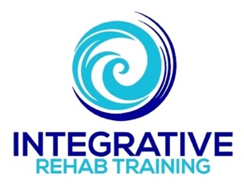

Manual therapy overview:
Considerations & techniques

Michael J. Mullin, ATC, PTA, PRC

Orthopedic Manual Therapy
- What constitutes orthopedic manual therapy
  - Each application is used for the purposes of modulation of pain, reducing or eliminating soft tissue inflammation, improving contractile and noncontractile tissue repair, extensibility, and/or stability and increasing ROM for facilitation of movement and return to function.
    - Other techniques providing “dubious claims or mental, physical and behavioral changes”.
  - Proposed standardized manual therapy terminology

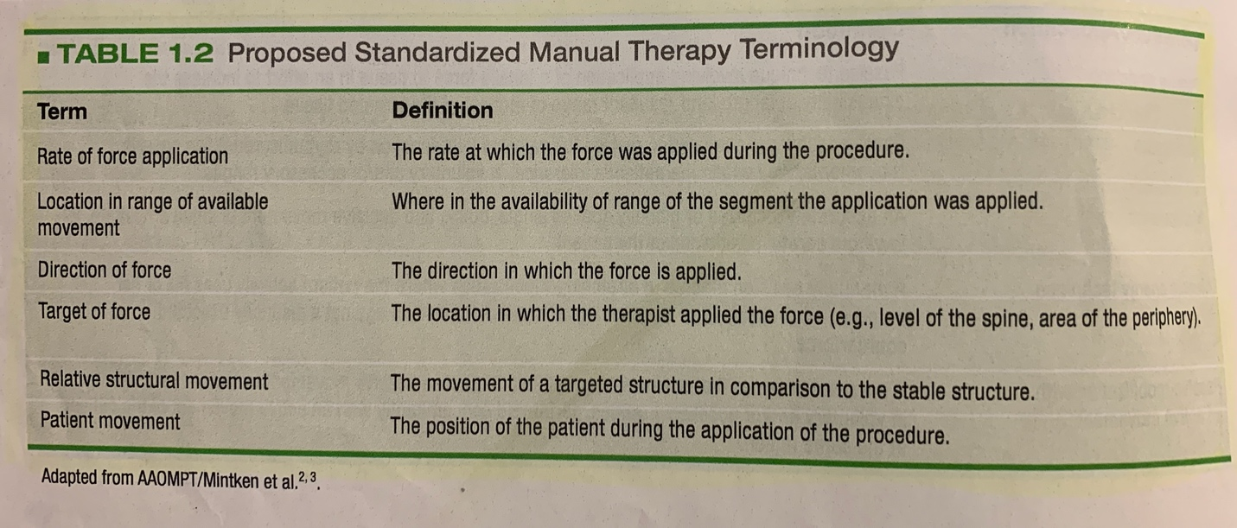

    - Rate of force application
    - Location in range of available movement
    - Direction of force
    - Target of force
    - Relative structural movement
    - Patient movement
  - Hypothesized effects of manual therapy

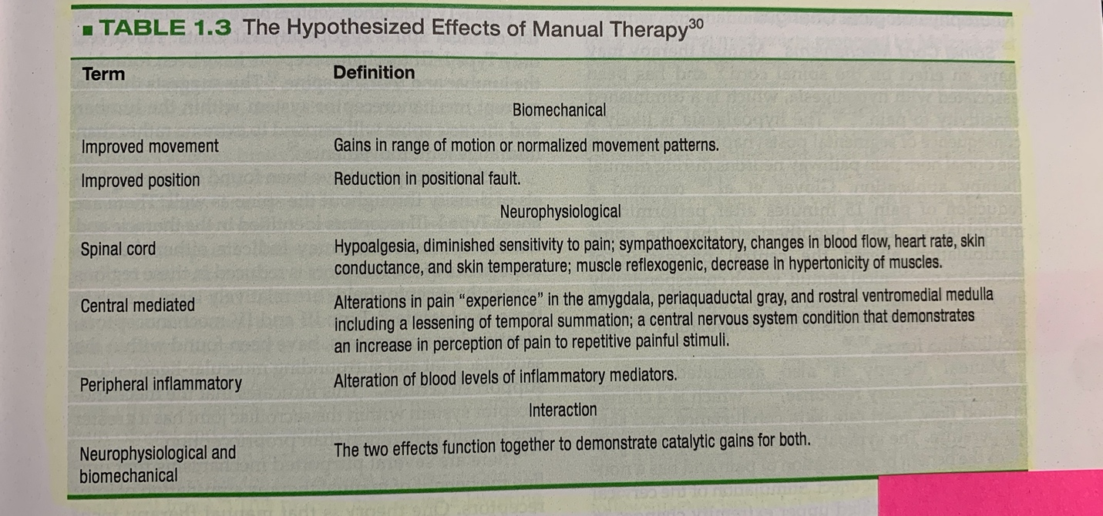

    - Most theories remain hypothetical, but all result in similar functional outcomes and comparable hypothesized effects with each improving one another--“catalytic gains for both”.
      - Biomechanical
        - Improved movement
        - Improved position
      - Neurophysiological changes
        - Spinal cord mechanisms
          - Sympathoexcitatory response
        - Central mediated mechanisms
          - Central facilitation
          - Reduction of afferent nociceptive input to the CNS
          - Gate control
        - Peripheral mechanisms
          - Inflammatory markers and changes in pH in damaged tissue has been demonstrated, changing the pH structure, potentially resulting in decreased pain.
      - Psychological
        - Placebo
          - Qualitative in nature (based on perception) but can lead to quantitative changes.
        - Satisfaction and expectation
        - Psychological covariates
          - Tissue damage and complexity of ascending pathways to brain and descending pain-suppressing systems.
          - Perception and interpretation of a wide-range of incoming stimuli.
        - Emotions
          - Anxiety, fear, depression and anger are the four emotions that best characterize the distress of those with chronic pain.
  - Hierarchy of evidence
    - The hierarchical pyramid of evidence

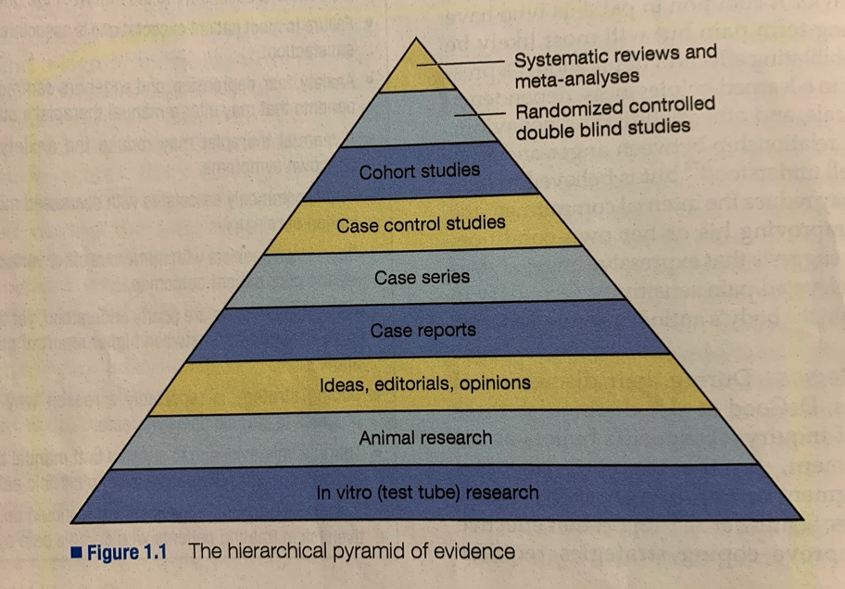

    - The 5S model for synthesizing and managing information

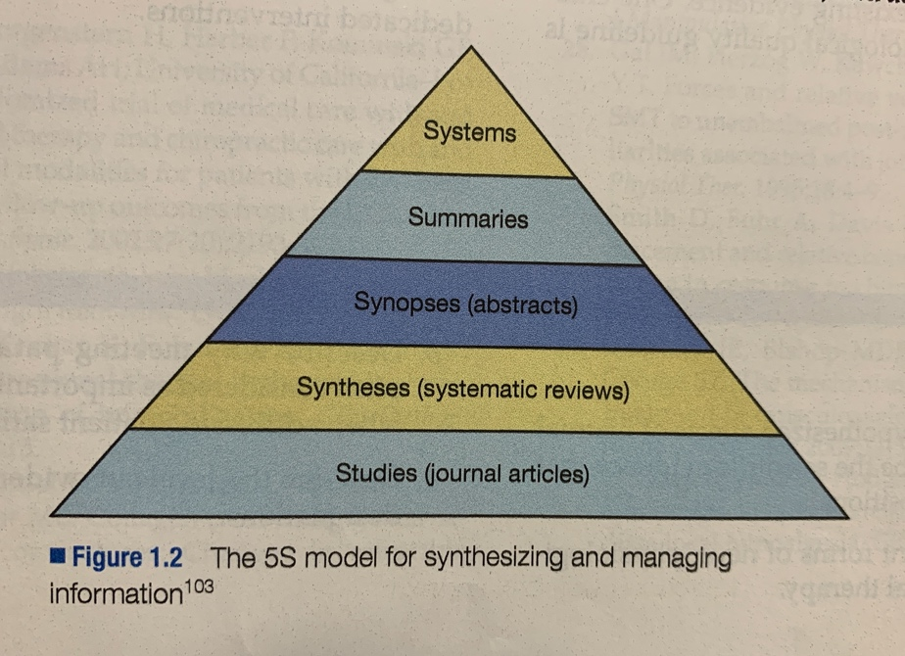

    - The four levels of evidence
      - Level A = strong evidence (high quality randomized controlled and meta-analysis)
      - Level B = moderate evidence (high-low quality randomized controlled)
      - Level C = limited/contradictory evidence (one high-low quality randomized and inconsistent otherwise)
      - Level D = no known evidence (not sufficiently studied)

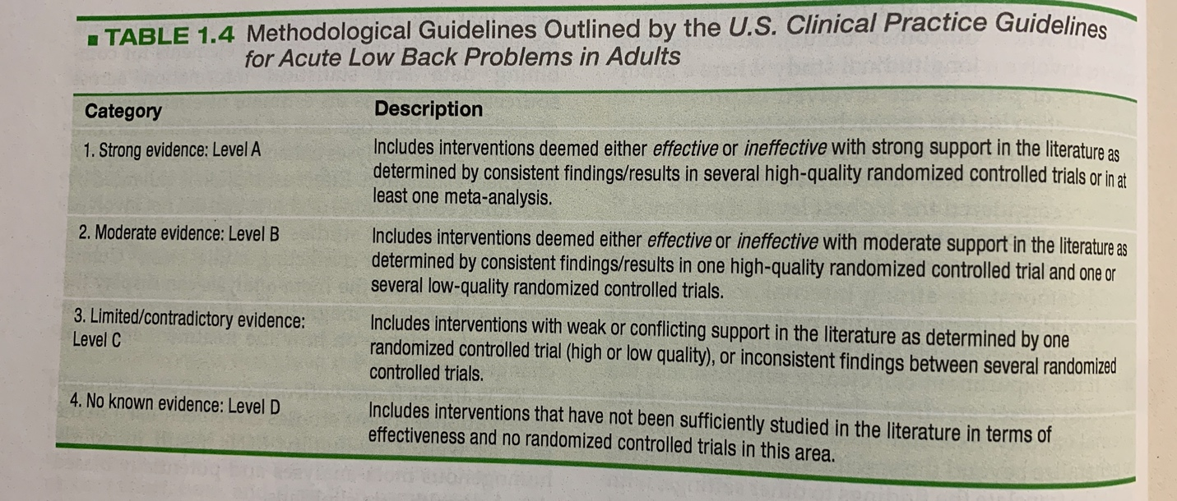

Orthopedic Manual Therapy Assessment
- Clinical decision-making models
  - Suggests it is along a spectrum of “right on one end and wrong on the other”
    - Patients are too complex for this to be true
    - Threshold effect
  - Hypothetical-deductive
    - Development of a hypothesis during the clinical examination and refuting or acceptance of that hypothesis as the examination progresses
    - Deductive reasoning, general to specific, bottom-up approach
    - Comprehensive, focused and quite extensive
    - Allows for pathognomonic diagnosis of a sign or symptom that is characteristic of a “red flag”.
      - Supplemented with use of special tests and standardized examinations
  - Heuristic decision making (clinical Gestalt)
    - Organize clinical perceptions into coherent construct wholes, indirectly made clinical decisions, pattern recognition, experience driven, top-down approach
    - Five potential faults
      - Representative heuristic (similarity)
      - Availability heuristic (frequency)
      - Confirmatory bias (substantiate)
      - Illusory correlation (deception)
      - Overconfidence (level of experience and inverse relationship)
  - Mixed model decision making
    - Ideal, as it allows for development of clinical prediction rules and use assessment modifiers such as probabilistic decision-making analyses to assign predictive values to pertinent findings
- Assessment modifiers and decision making
  - Outcome mediator
    - Functions to partially identify the possible mechanisms through which a treatment might achieve its effects.
    - Causal links between treatment and outcome—positively or negatively affect an outcome by virtue of a “change”
    - i.e. Perform an intervention and a change of some kind is noted
  - Outcome moderator
    - Baseline variable that is independent of the treatment itself
    - i.e. sociodemographic variables, genotype/archetype, baseline clinical characteristics (comorbidities)
  - Probabilistic decision making
    - Form of moderator, statistically sound, reduces judgement’s influence to address complexity and uncertainty
    - Bayesian assessment
      - aka, knowledge-based decision making
      - Predicated on prior estimates of probabilities, based on additional experience, and influenced by additive information
      - Use of clinical prediction rules helpful in establishing improved probability of success with a diagnosis or intervention when patient and assessment findings match these rules
  - Patient response triggers
    - Form of mediator, facilitates a dedicated care response, expectation of prognosis or diagnosis
    - Within-session vs between-session changes/outcomes
      - Used to adjust treatment dosage, intensity, and application
      - Both are useful
  - Classification or clusters
    - Has been demonstrated better outcomes than independent clinician decision-making
- Clinical reasoning
- Decision making in manual therapy
  - Philosophical variations robustly harbor influential internal biases that affect decision-making in manual therapy.
  - “Continuing education programs offer ‘new’ material, all of which have potential weaknesses.”
  - Widespread variations in manual therapy curriculums, approaches and exposures
    - Origin of structures often dictate the perspective of the particular model
  - Maitland, McKenzie, Mennell, Cyriax, Kaltenborn, Osteopathic and eclectic are most common models
    - Maitland
      - Comparable sign
        - Motion or combined motions that reproduced symptoms
        - Used four grades of oscillatory-based application and they differed in force, amplitude and objective
    - McKenzie
      - Classification based
        - Series of repeated movements and postural/positioning assessments to determine patient response
        - Assigned to one of three groups
          - Postural
          - Derangement
          - Dysfunction
    - Mennell
      - Subjective findings, joint dysfunction based on onset and presence of trauma
      - Utilized quick thrusts followed with active movements to encourage “muscular reeducation”.
    - Cyriax
      - Based on assessments of capsular patterns and results of resisted testing
      - Identification of “lesions”
        - Use of physiological movement, accessory movement or other treatment was dependent on pain-level, end-feel, capsular pattern, and presence of contractile or noncontractile lesion
    - Kaltenborn
      - Based on arthrokinematic movements based on convex-concave rules and to divide them into hyper- or hypo-mobilities
      - Utilized traction and accessory glides
    - Osteopathic
      - Interpretation of three potential findings
        - A positional fault
        - Restriction fault
        - And/or segmental or multi-segmental impairment
  - Philosophical analysis
    - Three primary assessment approaches in manual therapy
      - Biomechanical-pathological assessment analysis, consisting of assessments using capsular patterns, coupling motions of the spine, biomechanical movement theory, and treatment methods using convex-concave rules
      - Patient-response approach, which consists of movements and treatments based in patient report of symptom provocation and resolution.
      - Mixed method of both assessment models. This combined approach may rely more heavily on biomechanical assessment and patient response treatment, vice versa, or will use ad hoc

- Important coupling movements to always consider:
  - Flexion, abduction and external/lateral rotation
  - Extension, adduction and internal/medial rotation

Orthopedic Manual Therapy Clinical Examination
- Contraindications to orthopedic manual therapy
  - Recognize the importance of “red flags” and that there are varying levels of attention they require
    - Red flag categorization levels are not dissimilar to the levels of absolute and relative contraindications of both active and passive movements
    - (Do not concern yourself with manipulation considerations)
  - Absolute contraindications
    - Situation where the movement, stress, compression placed on the body part involves a (potentially) high risk of deleterious consequences
  - Relative contraindications
    - Situation which requires special care and reflection as to the necessity of performing vs an alternate intervention
      - Consider the patient’s presentation as well
      - Think twice so you don’t pay the price
      - BSTS (better safe than sorry)
  - Extra care should be taken when performing manual therapy around the upper cervical spine
- Detailed elements of the clinical examination process
  - Clinical examination helps determine what (re)produces the patient’s “familiar signs and symptoms”
    - Known as the concordant or comparable sign
  - Region-specific areas will typically follow this format:
    - Observation
    - Patient history
    - Physical examination
      - Structural differentiation tests
      - Active physiological movements
      - Passive physiological movements
      - Passive accessory movements
      - Special clinical tests
  - Three different examination domains
    - Observation
      - General inspection
        - More global, more visual outliers
      - Introspection
        - More local, more behavioral outliers
    - Patient history
      - Critical, not necessarily specific to the area involved, even the little stuff might matter
      - Mechanism of injury
      - Concordant sign
        - aka comparable sign
        - That movement which reproduces symptoms
        - Disconcordant sign
          - Movement that is painful or abnormal, but not related to the concordant sign
      - Nature of the condition
        - Severity of the disorder
          - Actual vs perceived
        - Irritability (or “reactivity”)
          - Both acute or chronic issues can have varying levels of irritability
          - Not necessarily reflective of the severity of the condition
        - Behavior of symptoms
          - Time
            - Over a period, pro- or regressive symptomology, response to self-interventions
          - Response to movements
            - Does a specific movement pattern exist in relationship to their symptoms
          - Area
            - Isolation in order to rule out associated factors proximal and/or distal to the condition
        - Pertinent past and present history
        - Patient goals
        - The baseline
          - Base “functional” performance or self-reported pain level
            - Visual analog scale (“pain scale”)
          - PROM and/or AROM
          - A “sense” of change
      - At the end of the observation and subjective history, the clinician should have:
        - Red flags ruled out
        - Post-subjective hypothesis
        - Appropriateness for manual therapy
        - Nature of the problem (as characterized by the severity, irritability and stage of the condition)
        - Patient’s expectations
        - Concordant sign which helps drive the examination and the treatment
          - Most important part of the manual therapist’s examination
    - Physical examination
      - Active movements
        - Performed solely by the patient
        - Three stages of this assessment and patient response during these stages
          - Initial—Patient moves to first point of pain (response is noted)
          - Progressive—Patient moves beyond the pain and holds (response is noted for change)
          - Repeated—Patient then repeats the movement to determine if pain or range changes (if they are able to move past this point)
          - Overpressure—Should be considered as well to differentiate concordant from disconcordant and see if symptoms are still present
        - Three questions should be asked
          - Was there an improvement in pain symptoms, range of motion, quality of motion or a combination?
          - If symptoms were produced, how did they respond to repeated movements?
          - Where in the range did the symptoms worsen?
            - End-range usually suggests mechanical impairment, mid- or through-range suggests inflammation or instability
      - Passive movements
        - Passive physiological movements
          - “Movements which are actively used in the many functions of the musculoskeletal system”
          - Osteokinematic motions through plane-based descriptors (flexion, extension, abduction, adduction, medial and lateral rotation)
          - Occur simultaneously with accessory motions and degree of freedom and motion availability is a product of that accessory motion
          - Helps determine total ROM at a particular joint
          - Follows active physiological process of initial, progressive and repeated movements toward concordant sign
        - Passive accessory movements
          - “Any movement manually or mechanically applied to a body with no voluntary muscular activity by the patient”
          - Divided into regional and local mobilizations
            - Regional is directed passive movement to more than one given area, segment or physiological component
              - Spinal techniques mostly regional
            - Local mobilization is specific and directed to one segment and/or joint area
              - Require locking of adjacent joint areas and is facilitated by apposition when joint surfaces are most congruent and ligamentous structures maximally taut
          - Can be performed in open-packed or closed-packed positions
        - Combined passive movements
          - Habitual movements that occur in combination of planes rather than as pure movements in one plane
          - Follows active physiological process of initial, progressive and repeated movements toward concordant sign
          - Can occur in any one of a number of different combined active and/or passive movements
        - Other considerations
          - Magnitude of force
            - Enough force is required in order to create change to effectively analyze
          - Rate of increase of force
            - Increase in frequency will result in increase in resistance to deformation
          - Duration of loading
            - Repeated loads over time leads to greater stiffness at end-range
          - Targeted tissue to which force is applied
            - Lots of variables can influence outcome
          - Location of manual force in relation to the center of the targeted structure
            - Starting point should be near the center of the targeted structures
          - Direction of force
            - Lots of variables which can influence outcome
          - Contact area over which the force is applied
            - How and where one grasps the targeted area
      - Special clinical testing
        - Includes palpation and manual muscle testing
        - Four purposes
          - Supportive information
            - Determine the level of functional impairment or disability
            - Isolated clinical assessment tools not as effective
          - Diagnostic value
            - To a set of findings using sensitivity and specificity values and offshoots
            - Add to hypothesis but rarely help confirm a diagnosis
          - Prognosis of the patient
            - Can either directly tie a finding toward an outcome or cluster findings that dictate the use of a decision “rule”
          - Structural differentiation
            - For use to help clinician correct origin of the dysfunction when coupled with other differentiation tests, especially when other factors have not helped target the source
    - Putting objective physical examination findings together
      - At this stage, the clinician should have an understanding of:
        - Causal pain-generating region
        - Which active movements increase, decrease or normalize the pain (associated with the concordant sign) or ROM
        - Which passive movements increase, decrease or normalize the pain (associated with the concordant sign) or ROM
        - Potential pain generators based on movement, positional or palpatory findings
        - Potential diagnosis based on examination and clinical test findings
        - Association of subjective and objective findings

- Techniques
  - Static stretching
  - Mobilization
    - Segmental/joint mobilization
    - Nerve mobilization
    - Soft-tissue mobilization
    - Targeted specific manipulation
    - Generalized manipulation
  - Combined techniques
    - Mobilization with movement (MWM)
      - Term coined by Brian Mulligan and is the application of an accessory glide during the patient-driven active physiological movement.
      - Accessory application should follow the biomechanical joint orientations and the sustained, through-range, manually derived forces that guide the joint in such a way that superimposed active movement, which previously produced pain, can then occur painlessly.
      - Follows Kaltenborn’s principles of restoring the accessory component of active and passive physiological joint movement.
  - Alternate techniques
    - Strain-counterstrain (S/CS) / Positional Release Therapy (PRT)
      - Passive indirect technique developed by Dr. LH Jones in 1955 based on pain-relief from “tender points” (TPs) and improved function from being in pain-free positions.
      - TPs are small, edematous, hypersensitive areas located at myofascial and articular areas that are elicited upon palpation
      - Typically located near muscular attachments to the bone, overlying tendons, the belly of major muscles and at or around joints
      - Assume the patient or region in a pain-free position and maintain while palpating the “wobble point” for 90 sec to relieve the strain
    - Craniosacral therapy
      - Founded by the work of William Sutherland, DO from the teachings of Andrew Still, MD
      - Gentle hands-on technique that uses light touch to examine membranes, fascia and movement of the fluids in and around the central nervous system
      - Aims to promote feelings of well-being by eliminating pain and boosting health and immunity
    - Cranial manual techniques
      - Founded by the work of William Sutherland, DO from the teachings of Andrew Still, MD
    - Visceral manipulation
      - Founded upon by Jean-Pierre Barral, DO, PT
      - Gentle manual therapy that assess the structural relationships between the viscera (organs) and their fascial or ligamentous attachments to various parts of the body
      - Assists in restoring structural imbalances throughout the body
    - Muscle Energy Techniques (MET)
      - Developed by Fred Mitchell, DO in 1948
      - Uses the muscle’s own energy in the form of gentle isometric contractions to relax the muscles via autogenic or reciprocal inhibition and lengthen the muscle.
      - Autogenic Inhibition
        - Submaximal contraction of the muscle followed by stretching of the same muscle
      - Reciprocal Inhibition
        - Submaximal contraction of a muscle followed by stretching of the opposite muscle
    - Instrument Assisted Soft Tissue Mobilization (IASTM)
      - Skin, myofascial, muscles and tendons manipulation intervention utilizing various direct compressive stroke techniques.
        - Creates microtrauma to the affected soft tissue which causes a stimulation of local inflammatory response for reabsorption of inappropriate fibrosis or scar tissue.
      - Based on James Cyriax cross-friction massage and said to have evolved from Gua sha used in Chinese medicine.
      - Most commonly stainless steel instruments with beveled edges and contours.
        - There are wood and plastic instruments as well.
      - Is used both for detection as well as treatment.
      - Foam rolling and The Stick could also be considered IASTM.
    - Proprioceptive Neuromuscular Facilitation (PNF)
      - Developed by Herman Kabat (based on the work of Charles Sherrington)
      - Seems to have similar outcomes as static stretching.
      - Reversal of antagonists
      - Repeated contractions
      - Combined isotonics
      - Rhythm initiation
      - Contract-relax
      - Hold relax
      - Replication
      - Resisted progression
      - Rhythmic rotation
    - Manual lymph drainage (MLD)
      - A light, skin-stretching massage that helps promote the movement of lymphatic fluid out of an extremity via focused work on lymph vessels to help this flow.
      - Unaffected areas first to allow fluid to move out of the affected area(s), or “decongest” the region.
      - Four main strokes:
        - Stationary circles
        - Scoop technique
        - Pump technique
        - Rotary technique
      - Coupled with breathing activities to assist in pumping.
    - Trigger point
      - Hyperirritable spot, a palpable nodule in the taut bands of the skeletal muscle’s fascia. Direct compression or muscle contraction can illicit a:
        - “Jump sign”
          - Characteristic behavioral response to pressure on a TrP. Startled by intense pain, seemingly out of proportion to the amount of pressure applied and often met with reflexive reaction elsewhere in the body.
        - Local tenderness
          - See above
        - Local twitch response
          - Transient visible or palpable contraction of the muscle and skin as the tense muscle fibers contract when pressure is applied
        - Referred pain
          - Also called reflective pain, which usually responds with a pain pattern distant from the spot
          - Does not follow dermatomes, myotomes or nerve roots
          - These TrP referred pain sites have been mapped (i.e. Janet Travell)
    - Integrative Manual Therapy (IMT)
      - Developed by Dr. Sharon Weiselfish-Giammatteo
      - Uses the body as a whole to treat pain, dysfunctions, disabilities that prevent the body’s own capabilities of healing itself
      - Addresses rehabilitation in two categories
        - Structural
        - Functional
      - “Tri-planar fascial fulcrum”
    - Controlled Articular Rotations (CAR’s) from Functional Range Conditioning (FRC)
      - PAIL’s and RAIL’s
        - Progressive angular isometric loading and regressive angular isometric loading
      - Designed to teach the nervous system how to control progressively larger ROM’s (Principle of Specificity) and prepare the body’s tissues to function in newly acquired ranges (Progressive Adaptation)
    - Active Release Technique (ART)
      - Soft tissue method which focuses on relieving tissue tension via the removal of fibrosis/adhesions which can develop in tissues as a result of overloading/repetitive use.
      - Both diagnostic and treatment
      - To restore free and unimpeded motion of all soft tissues
      - To release entrapped nerves, vasculature and lymphatics
      - To re-establish optimal texture, resilience and function of soft tissues
    - Feldenkrais Method
      - Developed by Moshe Feldenkrais
      - Utilizes gentle, mindful movement to bring new awareness to the body
    - Trager Approach
      - Developed by Milton Trager, MD
      - Not a technique, but an approach to meet the needs of the individual with soft, gentle touch and movements
      - Releases and relaxes emotional states and body tensions and pains

References:
- Orthopedic Manual Therapy: An Evidence-Based Approach, by Chad E. Cook; Pearson Education, Inc, 2012. (Chapters 1-3: Orthopedic Manual Therapy, Orthopedic Manual Therapy Assessment, Orthopedic Manual Therapy Clinical Examination)
- Multiple course manuals, textbooks, and online references

