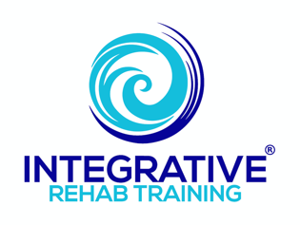

Earthing / Grounding Super Simplified

- The Earth has a natural electric charge which is constantly being recharged from electrical storm activity, the inner core, The Sun’s energy and a little from cosmic energy from space.
- Living organisms in direct contact with The Earth’s surface absorb this natural current which helps stabilize and balance out the internal electrical and chemical activity of the organism.
  - See “Earthing/Grounding” handout for much more detailed information on what happens and how the body benefits).
- A significant amount of research has been conducted and has demonstrated that bare skin contact with The Earth has profound health benefits in a number of different ways.
  - See “Earthing references & supplemental information”.
- It is most easily accomplished by walking barefoot on The Earth—grass, dirt, sand, beaches, rocks and roots, etc. Hand and other skin contact is equally beneficial as well.
- Trying to get 20-30 minutes of bare skin contact every day (at least) should be part of any overall health and wellness plan.
- Commercially products such as mats, pads, blankets, etc. are available which can provide similar benefits for those unable to access bare skin contact as readily.
  - It is important that people research the companies from which they consider purchasing products from as there are increasingly more online companies trying to provide products in this poorly regulated market.
  - “Earthing” and “Grounded” are a couple of the more reputable companies providing information and products.
  - Ideally products should be connected to a ground rod inserted directly into The Earth (while it does not go unrecognized that this provides a challenge for some people).

