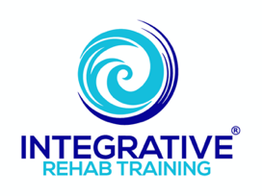

Grounding / Earthing

The word “grounded” or “grounding” can take on many different meanings:
- Feeling present, steady, supported, calm and in control of one’s brain and body—mental and emotional stability.
- Being able to sense/perceive one’s body weight and gravity’s influence on the system.
- To give something (i.e. a statement) a firm theoretical or practical basis.
- A form of punishment wherein one is prohibited from engaging in activities they enjoy.
- Connecting an electronic device with the ground via a grounded electrical outlet.

However, there is another definition that does not often get discussed yet warrants attention:
- Bare skin contact from our feet or other parts of the body with the Earth or other surface (i.e. mat, pad, sheets) which has been connected to the ground from a conducting cable.

And this last definition can not only have a positive influence the first two definitions—helping improve one’s mental and emotional state of mind and sensing/perceiving how gravity influences our body’s movement ability—but from a health perspective, Grounding, or Earthing, has demonstrated it can also be helpful in many other elements of human health and disease. Research from various sources has demonstrated that it can be helpful with:
- reduced inflammation
- decreased pain
- better sleep
- reducing cortisol levels
- Increases production of melatonin
- improved blood flow
- reduced blood viscosity
- hypertension
- accelerated wound healing
- facial skin health
- reducing stress and balancing the nervous system and heart function
- improvements in HRV (heart rate variability)
- prevention and reduction of symptoms from Covid-19 infection
- provides primary source of cellular restoration and energy
- supporting the electrical pulses/currents across membranes which create action potentials (information for correct movements, thoughts, behaviors, etc.)
- stabilizing the vagus nerve and electrical activity in the brain
- improving mood and overall sense of well-being
- reducing post exercise muscle soreness (delayed-onset muscle soreness or DOMS)
- helps shield the body against EMFs (low frequency electromagnetic fields)
- reducing muscle damage after strenuous eccentric exercise
- supporting overall health

But how does it work?
- The human body runs on electricity—it is essentially a fluid-filled sack of particles carrying charges through a multitude of circuits throughout our body. It is what allows our cells to function properly, allowing messages and information to flow to and from the brain and the body. Every movement or thought, every beat of the heart, every immunological response, is based on frequencies and electric transmissions in the body.

- The daily rhythm of chemical and hormonal cycling in the body is regulated and maintained by faint, natural electromagnetic signals generated in part by electrons from the Earth. It is part of what allows our bodies to cycle through its various biologic rhythms (i.e. sleep-wake cycle or circadian rhythm, activity-rest cycle or ultradian rhythm, nasal cycle, etc.). For proper messaging to occur, it requires a healthy, stable cellular environment for these to function in.

- In today’s world, we are being bombarded with different types of synthetic (artificial) electrical charges throughout the day which can create a build-up of what are called free radicals. Free radicals are unstable molecules in our system trying to find a way to stabilize—meaning they are looking for a negative electron in order to pair up with to neutralize or balance themselves. They can do this by “stealing” electrons from other healthy cells, potentially causing damage to them.

(Free radical “stealing” an electron from a healthy cell)
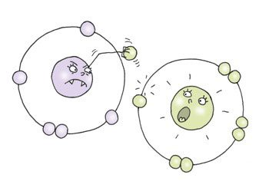

- These free radicals produce what is called oxidative stress or oxidization. This oxidization process creates an unhealthy environment for healthy cellular function. Some of the regions of the cell are attacked and they do not have a healthy defense system in place to ward this off, affecting the ability of normal processes to occur.

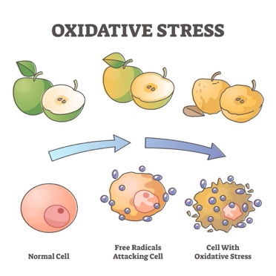

- The Earth, in many ways, is like a giant battery that is constantly being recharged from a variety of different sources—most notably through electrical storm activity, which is taking place all the time, all over the world (i.e. thunder/lightning storms). This, along with general atmospheric currents, creates a high level of free electrons, which are negatively charged parts of an atom that are not bound to its nucleus. This provides the Earth with a natural capacity to absorb electrical charges—which is why things which use electricity need to be “grounded” in order to stabilize their current.

- When the human body is in direct contact with the Earth’s surface, it immediately begins to absorb these free electrons into the system—they are effectively being pushed into the body—which can then act as antioxidants, helping to stabilize potentially ongoing cellular damage as a result of the free radical activity.

Free electrons donating to a free radical
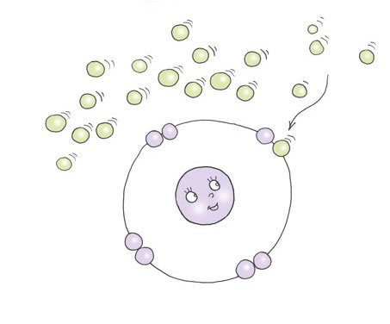

- Bringing things back to where this document started with the definitions of “grounding”, if we look at things from the standpoint of optimizing our physical and mental health and well-being, the first two definitions are incredibly important—being mentally and emotionally stable and being able to sense/perceive one’s body weight and gravity’s influence on the system. Since our body as a living organism requires a balance of electrical currents for important signals to be sent throughout it for stability, balance, and to work optimally—what is called homeostasis of the body—we can then apply the last definition of “connecting an electronic device with the ground” to all of this and the concept of “grounding” then likely makes much more sense. The only real difference is that our bodies are absorbing this energy from the Earth to neutralize itself for its daily use while electrical conduction from homes, businesses, power plants, etc. are using the Earth as a path for excess electricity to escape.

What are the best ways to acquire its benefits?
- Anything that allows bare feet or bare skin contact with:
  - Grass, dirt, sand and soil
  - Plants & living trees (especially wet bark)
  - Gravel & rock that is touching the Earth
  - Bodies of water (lakes, streams and especially the ocean)
  - A commercially produced mat, pad, sheet, patch, etc. which has been connected via a wire or cable to (** See supplemental information below):
    - a copper rod, copper coated steel rod, or commercially produced ground rod inserted directly into the ground (ideal)
    - the ground port of a properly grounded electrical outlet (**good, but not quite as ideal)
  - While any amount is beneficial, at least 20-30 minutes seems to yield the most benefits. The more the better.

Some other general take-aways:
- Like most anything, people respond differently to things. Regardless of whether it feels like is “working” or not, some people may notice a physical effect on their body while other people may not notice anything at all. Sometimes there is an immediate change and perhaps a lasting effect, while other times people may not notice much even after regular use, despite its underlying overall benefits.
  - Similar to eating well, it has cumulative effects and is just as much about aiding the system in working well as it is about helping ward off problems. It helps to naturally boost one’s internal defenses.
- The human organism is no different than other living things on our planet—an important part of what allows organic structures to flourish is being able to access and integrate the Earth’s natural electrical and magnetic charges in order to move needed materials in and out of cells.

Author’s further insight:
- The supplemental handout of references and links in this article should provide readers with other sources they can easily access to read for themselves to better understand this concept. With that, the author fully appreciates a few things regarding this topic:
  - The published research does not come from some of the more highly respected journals in allopathic medicine.
  - The simplicity of its influence could easily be disregarded as “we would be informed of its benefits from more sources”, “it would be discussed more in the medical world and with the lay public”, etc.
    - Much like the incredible importance of nasal breathing on human health, it is unfortunately not discussed almost at all with people as an integral part of human health, improved function and aiding in the ability to help ward off disease and inflammation.
  - The role that the placebo affect might play on outcomes.
    - Weighing risk:reward, pretty low risk with the potential for high reward.
- The author has had a multitude of positive outcomes and perceived benefits from Grounding with himself and his clients and highly recommends it as part of an integrated health plan.
- Research has been clearly demonstrated that “most of the degenerative diseases that afflict humanity have their origin in deleterious free radical reactions”.
- The pervasiveness of varying types and amounts of electromagnetic fields (EMFs) in our environment has been—and will continue to be—increasing over the coming years. It is the author’s very strong opinion based on considerable amount of self-education and “research” on this topic that there are a number of different ways that these have been and will likely continue to increase issues with our homeostasis and overall human health. The author feels all efforts should be made to try and educate & mitigate one’s exposure to these artificial waves of energy (refer to the author’s “Electromagnetic Fields (EMFs)” handout for further information).
  - Earthing/Grounding practices is one of the better ways to manage and actually offset the influence of these foreign fields of energy to the system.

** Due to the varying and often high amounts of electromagnetic fields (EMFs) in one’s home—especially the unknown variable of “dirty electricity” which can be emanating from a common household outlet—the use of the grounding cable into the third hole/safety part of the outlet (what is often called the “ground” part) cannot be guaranteed that it will provide the desired benefits. In some cases, while there is no electrical charge being produced by this cord into the third hole of the outlet directly, EMFs can jump on whatever potential conductor is close to them, thus it may be actually not only not helping, but actually potentially increasing some of the very things one is using the grounding mat/pad for to try and help.
Therefore, the use of this cannot be as strongly encouraged as having a cord attached to the mat/pad and attached to a rod inserted directly into the ground a little distance from the structure it is being used in if possible. There are many ways that can be found online which provide instructions on how to create this set-up, but the website from the company Earthing (www.earthing.com) has the grounding rod with a long cord and added extension cords if needed which connects to their products (as well as many other company’s products as well).

Disclaimer: This document should in no way be taken as medical advice. It is meant for educational purposes only and to provide research and evidence-based information. The author has found through a considerable amount of researching information as well as clinical experience and outcomes that Earthing can be a very viable and potentially powerful supplement to a healthy living experience.

